Question no_01: what is thread?

Answer of this question :

A thread is the smallest unit of processing that can be performed in an OS. In most modern operating systems, a thread exists within a process - that is, a single process may contain multiple threads.

Question no_02: what are different types of threads?

Answer of this question:

There are two types threads.User space thread and kernel space thread.

User space thread:

Executing code has limited access. API calls are used to the kernel to request memory and physical hardware access. Because of the restricted access, malfunctions within user mode are limited only to the system space they are operating within.

Kernel space thread:

Executing code has unrestricted access to any of the memory address space and to any underlying hardware. It is reserved for the highest of trusted functions within a system. Kernel mode is generally reserved for the lowest-level, most trusted functions of the operating system

question no_03: what are different implementation of thread?

Answer of this question:

Implementation of user space thread:

Can be implemented on an OS that does not suport kernel-level threads.Does not require modifications of the OS.Simple representation: PC, registers, stack and small thread control block all stored in the user-level process address space.

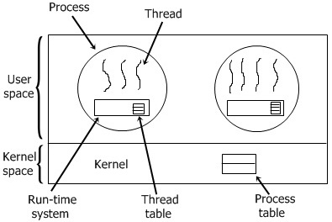

Implementation of kernel space thread:

The kernel has full knowledge of all threads.Scheduler may decide to give more CPU time to a process having a large numer of threads.Good for applications that frequently block.

